The We Count Recount: May 2021
We Count is a community-driven project that addresses the inherent bias against small minorities and outliers in artificial intelligence and data analytics.

A Message from Our Director
Friends and colleagues,
This National Accessible Awareness Week and Global Accessibility Awareness Day, we hope to address some of the underlying systemic barriers in our systems of research and decision-making.
During the pandemic we have become acutely aware of the underlying patterns that mean that the rich get richer and the popular gain more attention, while those that have neither fame nor fortune often feel that things are stacked against them. Our technical systems — whether they are recommender engines, financial markets or automated decision systems — amplify this pattern. This has contributed to the current accelerating disparities.
The primary focus of the We Count project has been to proactively intervene in the inequitable design of artificial intelligence and data analytics. However, the discrimination against small minorities and outliers existed well before these technologies and practices entered the public consciousness. They ripple through many of the practices we take for granted. Artificial intelligence systems merely optimize patterns of the past powered by data from the past.
Steffen Mau, in our recent webinar, spoke about the ascendance of quantification and measurement and the impact this has on things that are unmeasurable, making it harder to compete. Virginia Eubanks spoke about the vicious cycles of poverty fueled by self-perpetuating data analytics and automated decision systems. This month we will explore how these patterns impact competitive research funding and thereby knowledge and innovation for small minorities and outliers.
Grant competitions and how they are reviewed have a number of compounding factors that make it harder to find support for research into the concerns of small minorities. The researchers are judged by things like their publication and citation rates, and also their ranking in researcher impact factor scales. These are based on publications in high-impact journals that favour research methods that require quantitative statistical significance. This is usually not achievable when conducting research into small diverse groups with complex lives. The questions asked in funding competitions require a predetermined plan that doesn’t support co-design or community self-determination in the plan. This fixed plan prevents responsiveness to changing contexts. Success of a project is judged by numbers, where success is dependent on achieving impact with a single measure for the largest possible group. This doesn’t take into account the diversity of needs. Peer review perpetuates the current patterns and does not encourage peerless research.
This pattern has meant that people with minority needs have a harder time finding evidence, facts and acceptable proof when advocating for the supports or changes they need.
We will co-design proposed funding competitions suitable for community-led, bottom-up research that engages more inclusive research methods. Part of this work will be to co-design forms of evidence and data that are suitable for complex, variable, diverse lives. We hope you will join us.
All my best,
Jutta

News from the Field

Stories of Transformation, an Interview with Dr. Jutta Treviranus
In this Universal Design in Life and Work podcast episode, Dr. Jutta Treviranus talks about inclusive design versus universal design, AI bias and non-linear logic models.

Entering a New Digital Age for Accessibility and Inclusion
Did you know that a working draft of the W3C Accessibility Guidelines (WCAG) 3.0 was released on Jan 21? Read UX Collective's brief overview of the new guidelines.

The Success of Identity Technologies Depends on Diversity
Digital identities have the power to change access and open up a new world of inclusion, but half of the planet doesn’t currently have access to the internet and modern services. Discover how a lack of access curbs the potential innovation that comes with inclusivity.

Human-Centered AI: How Can the Technology Industry Fight Bias in Machines and People?
Featuring Renée Richardson Gosline, this installment of the MIT Sloan Experts Series looks at the consequences of how and when people trust bots and algorithms to help them make decisions and what it means for society at large.
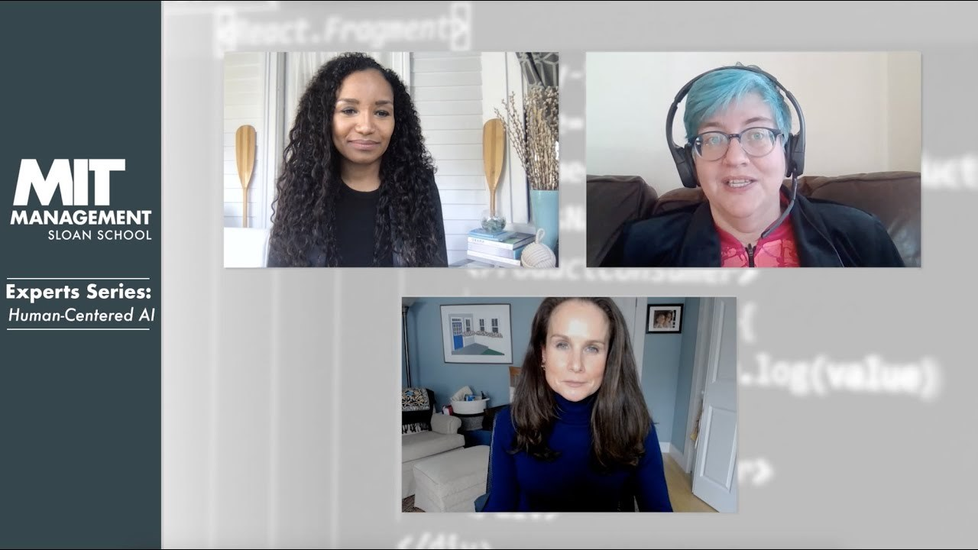
1 - Human-Centered AI

Turkish University Students Build Autonomous Wheelchair
Learn about a new autonomous wheelchair built by a group of Turkish university students that uses voice commands to operate the chair. The chair uses AI to help determine a safe and accessible route in the absence of an obvious/direct accessible route.

Machine Learning Catches Multiple Sclerosis-Related Gait Issues
Discover how a machine learning tool uses gait data to help clinicians monitor the progression of walking problems related to multiple sclerosis and learn about efforts to crowd source data from which these algorithms can learn.

This Month
OCAD U's 106th Annual Graduate Exhibition, GradEx, is on now. Have a look at the great work of our Inclusive Design Students.

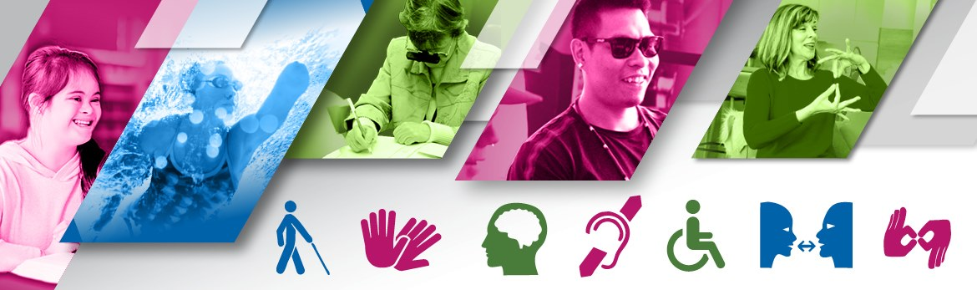
Mark your calendars! National AccessAbility Week is May 30 to June 5, 2021.

Initiatives

The Metric Society and the Unmeasurable
Last week's webinar, The Metric Society and the Unmeasurable, featuring Steffen Mau, Virginia Eubanks and Jutta Treviranus in conversation, was a fascinating discussion about the implications of how metrics have become a form of social conditioning.
If you weren't able to attend the webinar, a recording of the webinar will soon be available on the We Count website and YouTube channel.
2 - What Is a We Count Challenge?
Watch We Count's latest video and discover how we're helping to create an inclusive and balanced data ecosystem for persons with disabilities through our ongoing call for challenges.

Future of Work and Disability: Inclusive AI for HR
It's not too late to participate in our Future of Work and Disability webinar series!
Our third installment on Inclusive AI for HR provide insights for the development of standards and regulations that support diversity within data systems, with a particular focus on the ethical and transparent collection of data and the development of models and decision-making structures that recognize and respond to diversity. This webinar features:
Shea Tanis, University of Colorado
Rich Donovan, Return on Disability Group
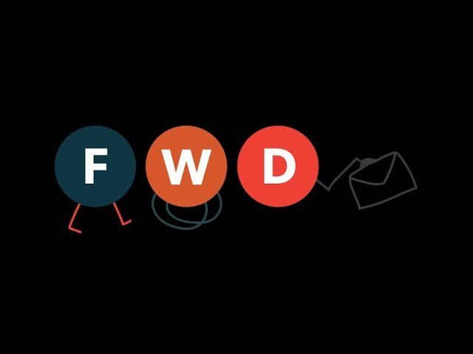
3 - Future of Work and Disability: Inclusive AI for HR
Visit our YouTube channel to see past webinar recordings. New videos are released regularly, so be sure to subscribe.

We Count Badges
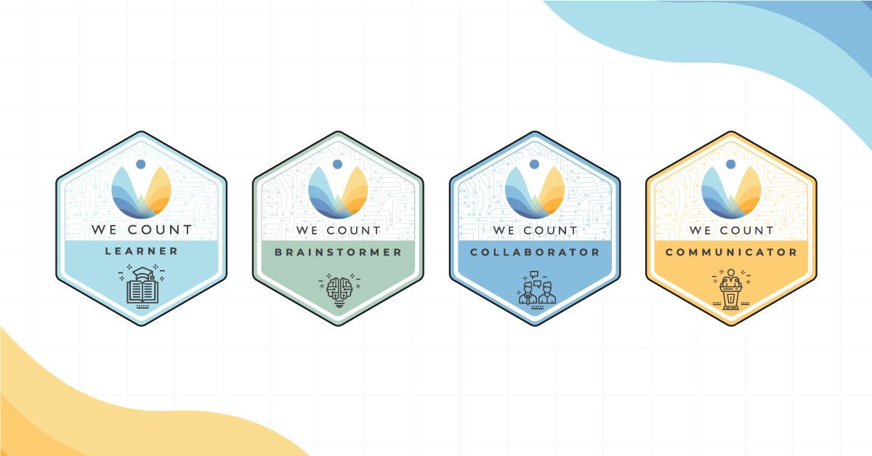
Earn badges with We Count! Our badges enable earners to showcase their proficiency in AI, data systems and inclusive data practices. To find out more about the types of badges we offer and which badges are currently available, visit our website.
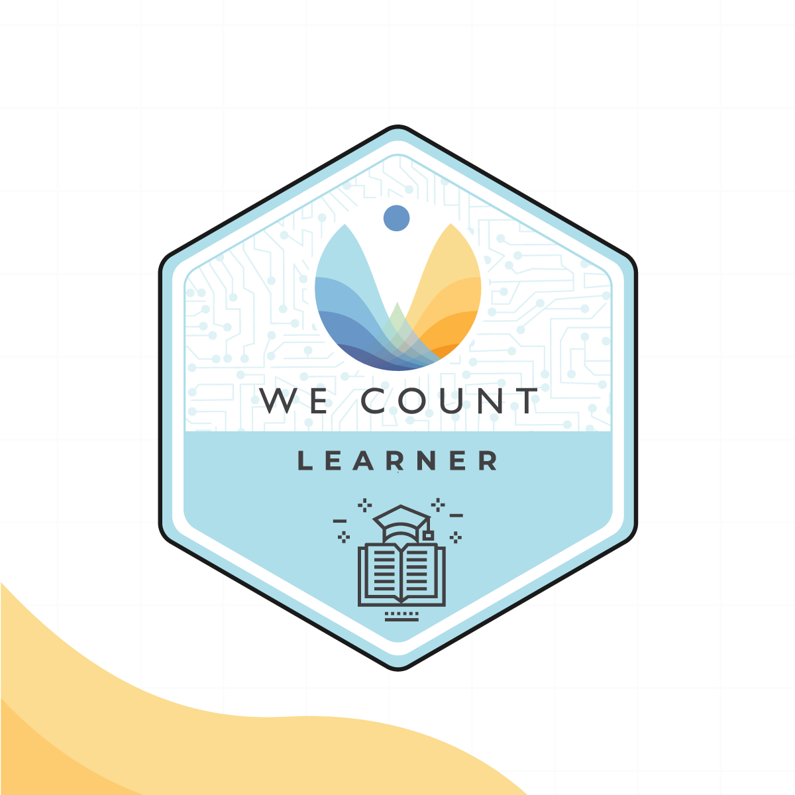

Badge Spotlight: Building Indigenous Future Imaginaries Learner Badge
Based on Jason Lewis’s research-creation work, this webinar explores the concept of the future imaginary and makes an argument as to why it is important that Indigenous people engage in creating them.
Machine learning, a subset of artificial intelligence (AI), depends on the quality, objectivity and size of training data used to teach it. We Count encourages participants and learners to explore this concept to help inform more equitable decisions and supports by understanding data gaps and biases.
You will learn:
How various Indigenous communities are contributing to AI technology to express and preserve their identity
How Indigenous ways of knowing are contributing to the global conversation regarding society and AI
Apply for this badge on our Initiatives page.

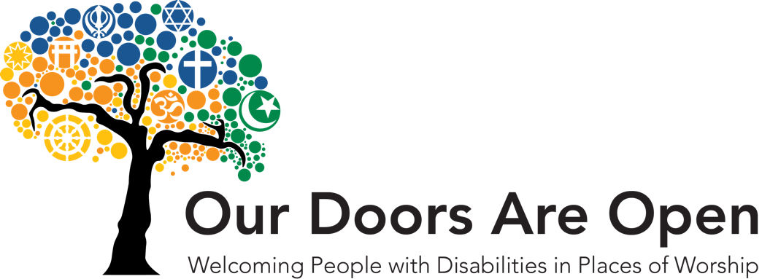
IDRC News

Our Doors Are Open continues with funding from the Calvin Institute. Our Doors offers faith communities in Ontario, Canada, and throughout the world, simple and creative ideas to help increase inclusion and accessibility for people with disabilities and enable their full participation. Since 2017, more than one hundred communities have received our workshop on accessible worship. Faith communities can register for a free, accessible online workshop.

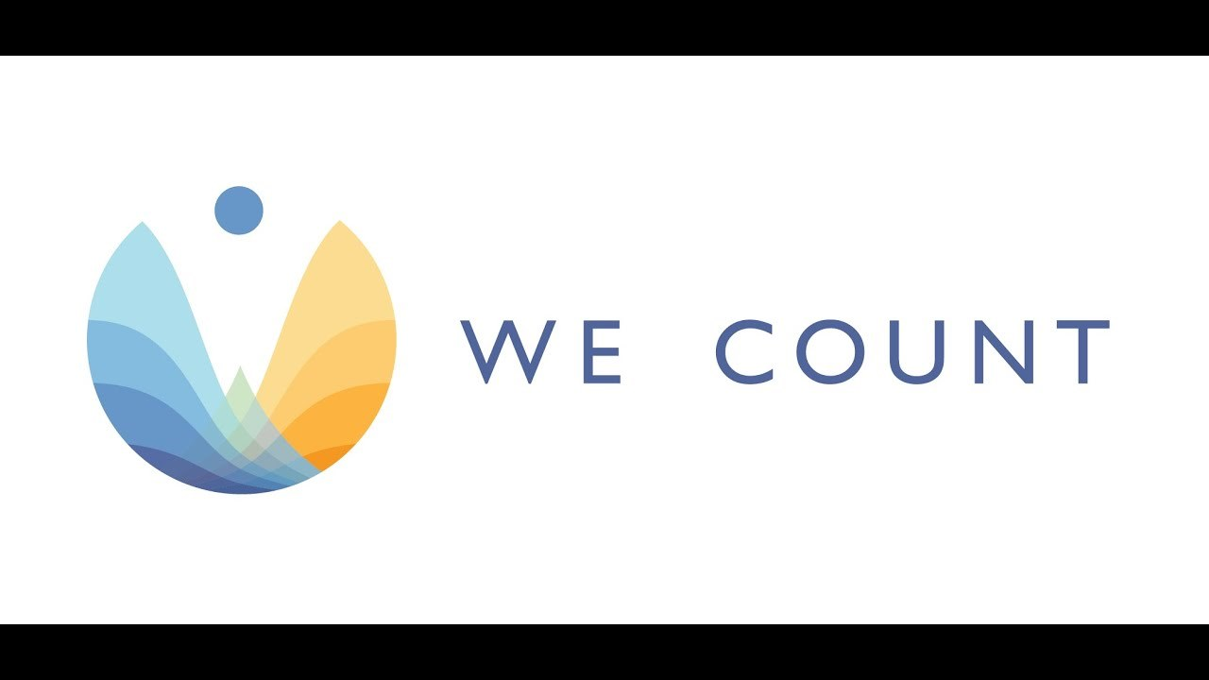
Learn More

Discover how We Count is addressing bias and developing new machine learning strategies that recognize and serve people with disabilities in this video.
Are you interested in hearing about We Count activities or do you want to be contacted to learn about ways you can participate? If you are, then send us your contact information using our contact form.

Contact Us
We would love to hear from you!
Inclusive Design Research Centre
OCAD University
205 Richmond St. W, Toronto, ON, M5V 1V3
wecount@inclusivedesign.ca
Visit the We Count website and follow us on social media (@WeCountProject).

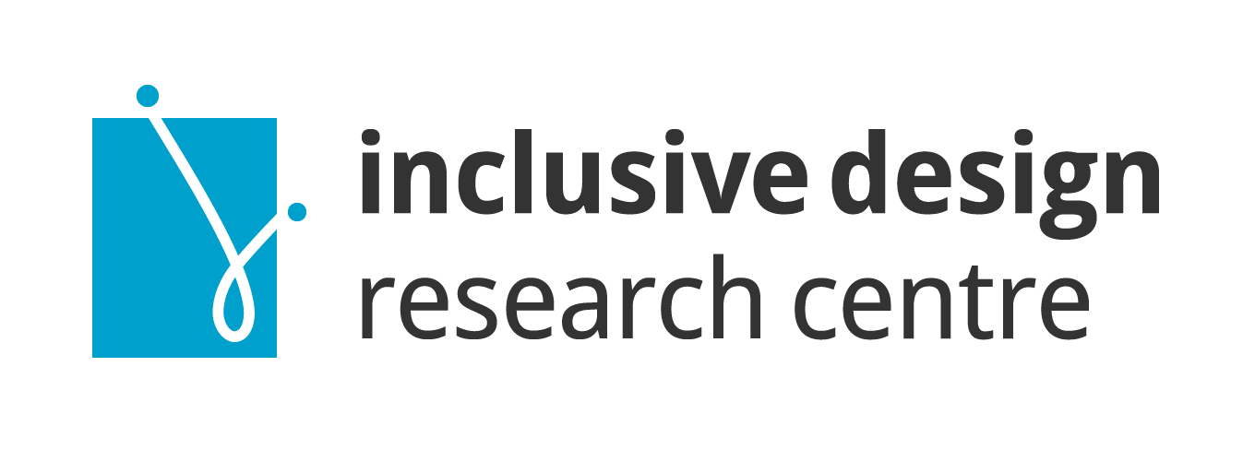
We Count acknowledges the support of:
