The We Count Recount: March 2021
We Count is a community-driven project that addresses the inherent bias against small minorities and outliers in artificial intelligence and data analytics.

A Message from Our Director
Friends and colleagues,
At the IDRC we are aware that the escalating innovations that change our lives are not designed for everyone. Often, the people that need them the most and are most vulnerable to the unintended harm, are the people that are excluded. This harms everyone eventually and impoverishes our society. We believe that to change this pattern requires the full participation of the communities that are currently excluded, from the very start. Unfortunately, the very process of innovation and design is structured to exclude. The language is not understandable. The issues are overwhelming and complex. Many important pieces of information are kept from the people that will feel the greatest impact. It is hard to participate meaningfully in a process when you don’t have the essential information.
Data science and artificial intelligence is one of these complex innovations that is sweeping through our world. If you are average or typical you can just trust that the innovation is made for you. You don’t need to get involved and you don’t need to understand the possible harms and benefits. If you live with a disability you don’t have this luxury. It is most likely that you will be the first to feel the unintended harms and new barriers. Unless you fight for the potential benefits, the market incentives will not naturally produce things for you.
This newsletter is a small step to address this. We hope to translate the obtuse geek speak and academic lingo so it is more understandable. We will find the important and relevant pieces of information in the overwhelming sea of chatter. We hope that it will make it possible for the most important people, those with lived experience of the barriers and opportunities, to participate meaningfully in this innovation.
All my best,
Jutta
PS: While writing this and feeling the enormity of the task before us, I heard the news that my dear friend Justin Clark has died. Words fail to express the sadness and loss, but the reflection on the magnitude of the change he wrought in his too short life bolsters my hope and resolve. If Justin can change the pattern of century-old institutions and mindsets with everything stacked against him, we can collectively push this innovation in more inclusive directions.

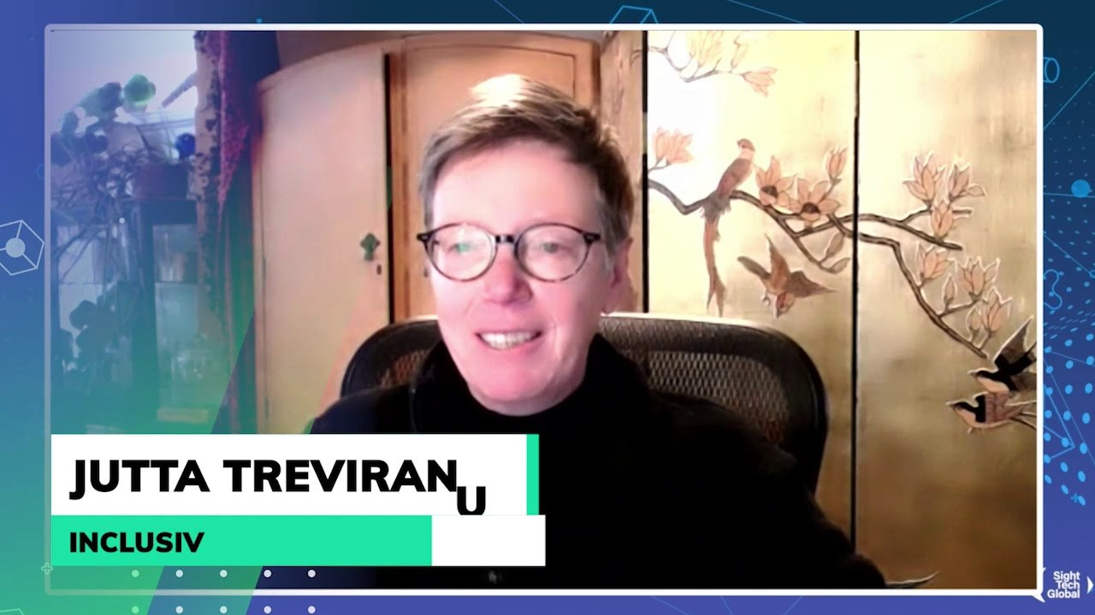
News from the Field

Auditing for Algorithmic Discrimination
A Computer Weekly article asserts that, despite the abundance of decision-making algorithms with social impacts, many companies are not conducting specific audits for bias and discrimination that can help mitigate their potentially negative consequences.

Disability Rights and Inventing the Accessible Future
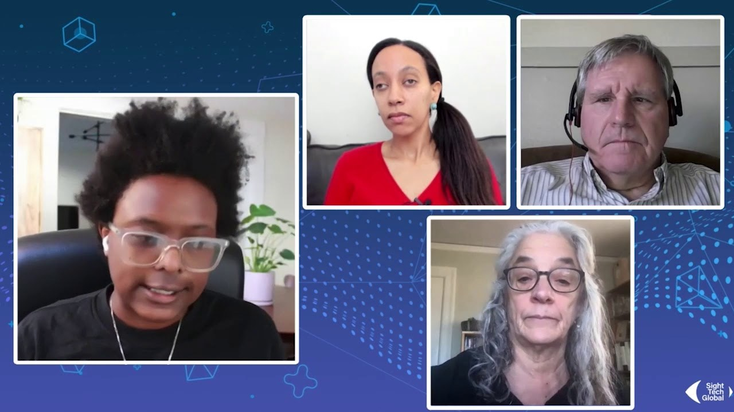
The Sight Tech Global 2020 Disability Rights and Inventing the Accessible Future panel discusses strategies for creating a future fully accessible to people with disabilities.

In AI Ethics, “Bad” Isn’t Good Enough
While AI ethicists focus on the harmful consequences of AI systems, this blog post discusses how we shouldn't conflate arguments that AI systems have harmful consequences with arguments about what we should do.
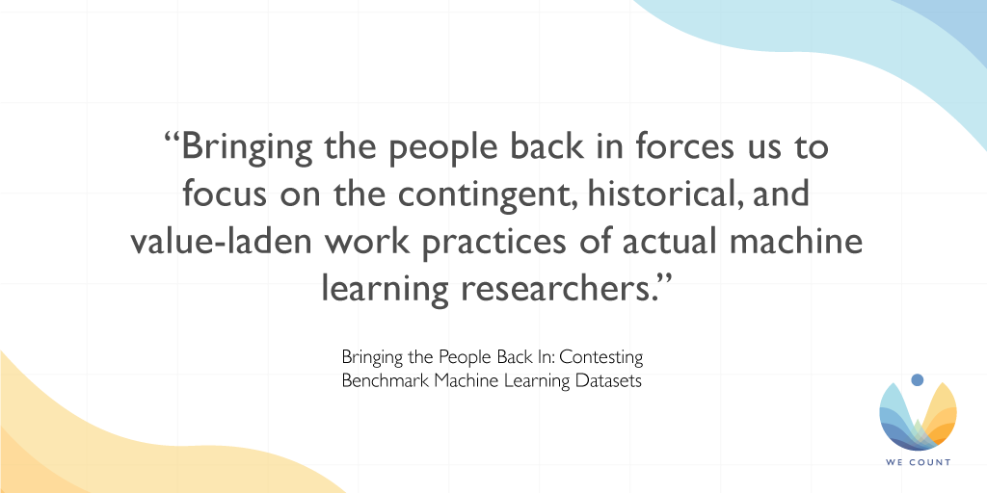

Bringing the People Back In: Contesting Benchmark Machine Learning Datasets
A new paper about the creation of datasets and the values that influence the choices of data collection.

Study Finds Diversity in Data Science Teams Is Key in Reducing Algorithmic Bias
A new study on the sources of bias among AI developers stresses how more diverse teams will reduce the chance for compounding biases. Read the VentureBeat article for more details.

Gender Shades
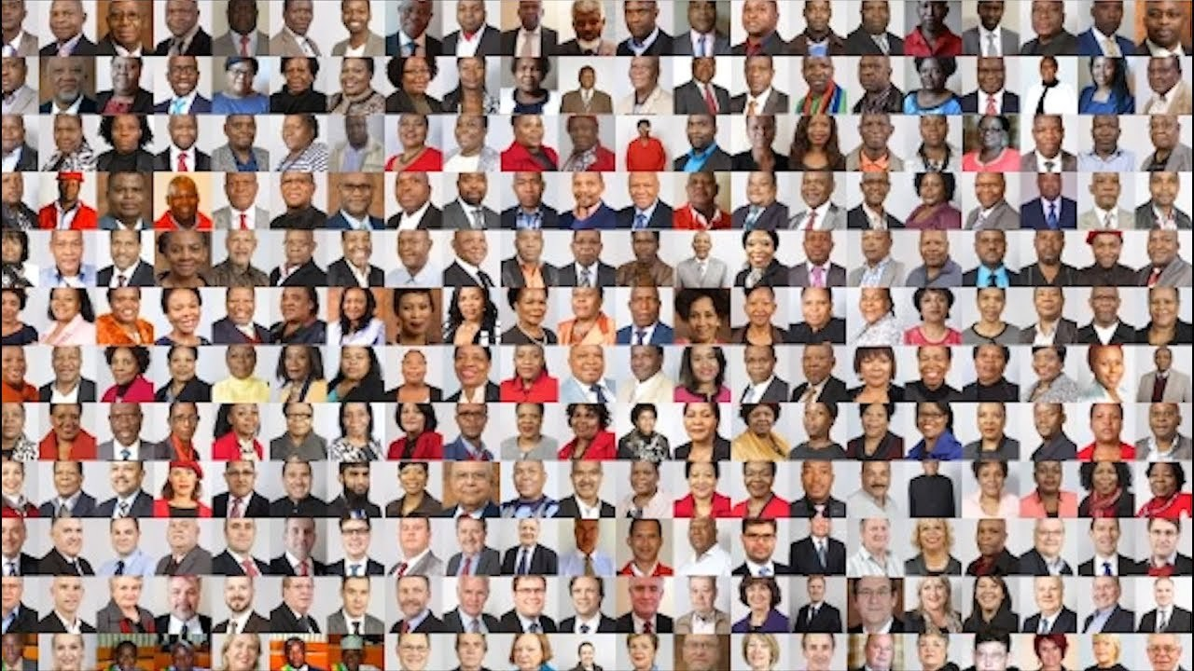
Explore the Gender Shades project and how it evaluates the accuracy of AI-powered gender classification systems, demonstrating the need for increased transparency in the performance of any AI products and services that focus on human subjects in this video.

The Robots Occupying Our Sidewalks
Technology companies often fail to design and develop AI with persons with disabilities in mind. As this TechCrunch article highlights, no-contact delivery robots are just one of many examples of this systemic issue.

Initiatives
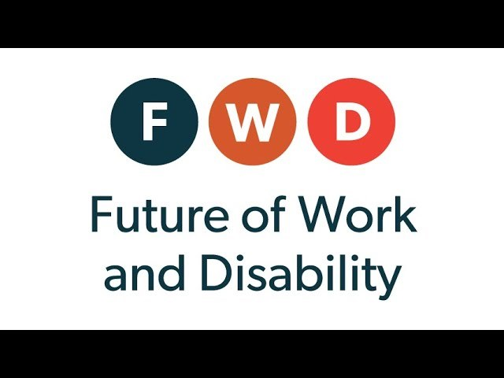
1 - Future of Work and Disability: AI Employment Systems
It's not too late to participate in our Future of Work and Disability webinar series!
Our first installment on AI Employment Systems provides an introduction to AI and machine learning with a focus on how AI creates barriers and opportunities for persons with disabilities in the hiring, training and retention of employees. This webinar features:
Anhong Guo, University of Michigan
Shari Trewin, IBM
Ben Tamblyn, Microsoft
Chancey Fleet, Data and Society
Visit our YouTube channel to see past webinar recordings. New videos are released regularly, so be sure to subscribe.

We Count Badges
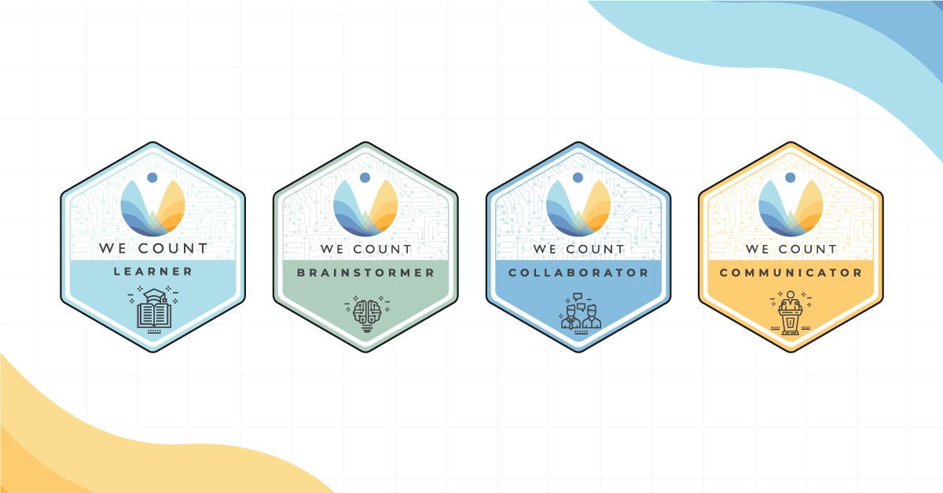
Earn badges with We Count! Our badges enable earners to showcase their proficiency in AI, data systems and inclusive data practices. To find out more about the types of badges we offer and which badges are currently available, visit our website.

IDRC News

Gender Equality in Science, Technology and Innovation
The IDRC is excited to be a partner in the Gender STI project. Gender STI is an international research project that aims to analyze the participation of women in science, technology and innovation (STI) dialogues between Europe and third countries. The project will focus on four key areas:
- Gender equality in scientific careers
- Gender balance in decision-making
- Integrating gender dimension in Research and Innovation (R&I) content
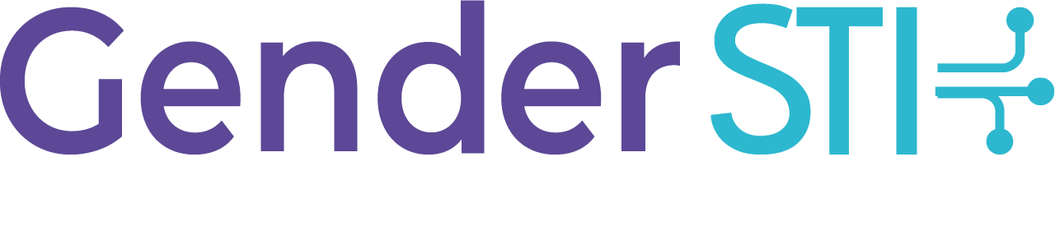
- Co-designing solutions to common challenges found in these areas through a design-thinking process
The Gender STI consortium is made up of partners from sixteen countries in four continents. The project is honouring International Women's Day 2021 with the #WomenInLeadership campaign, which celebrates women leaders in science, technology and innovation and sheds light on their journeys, challenges and goals.
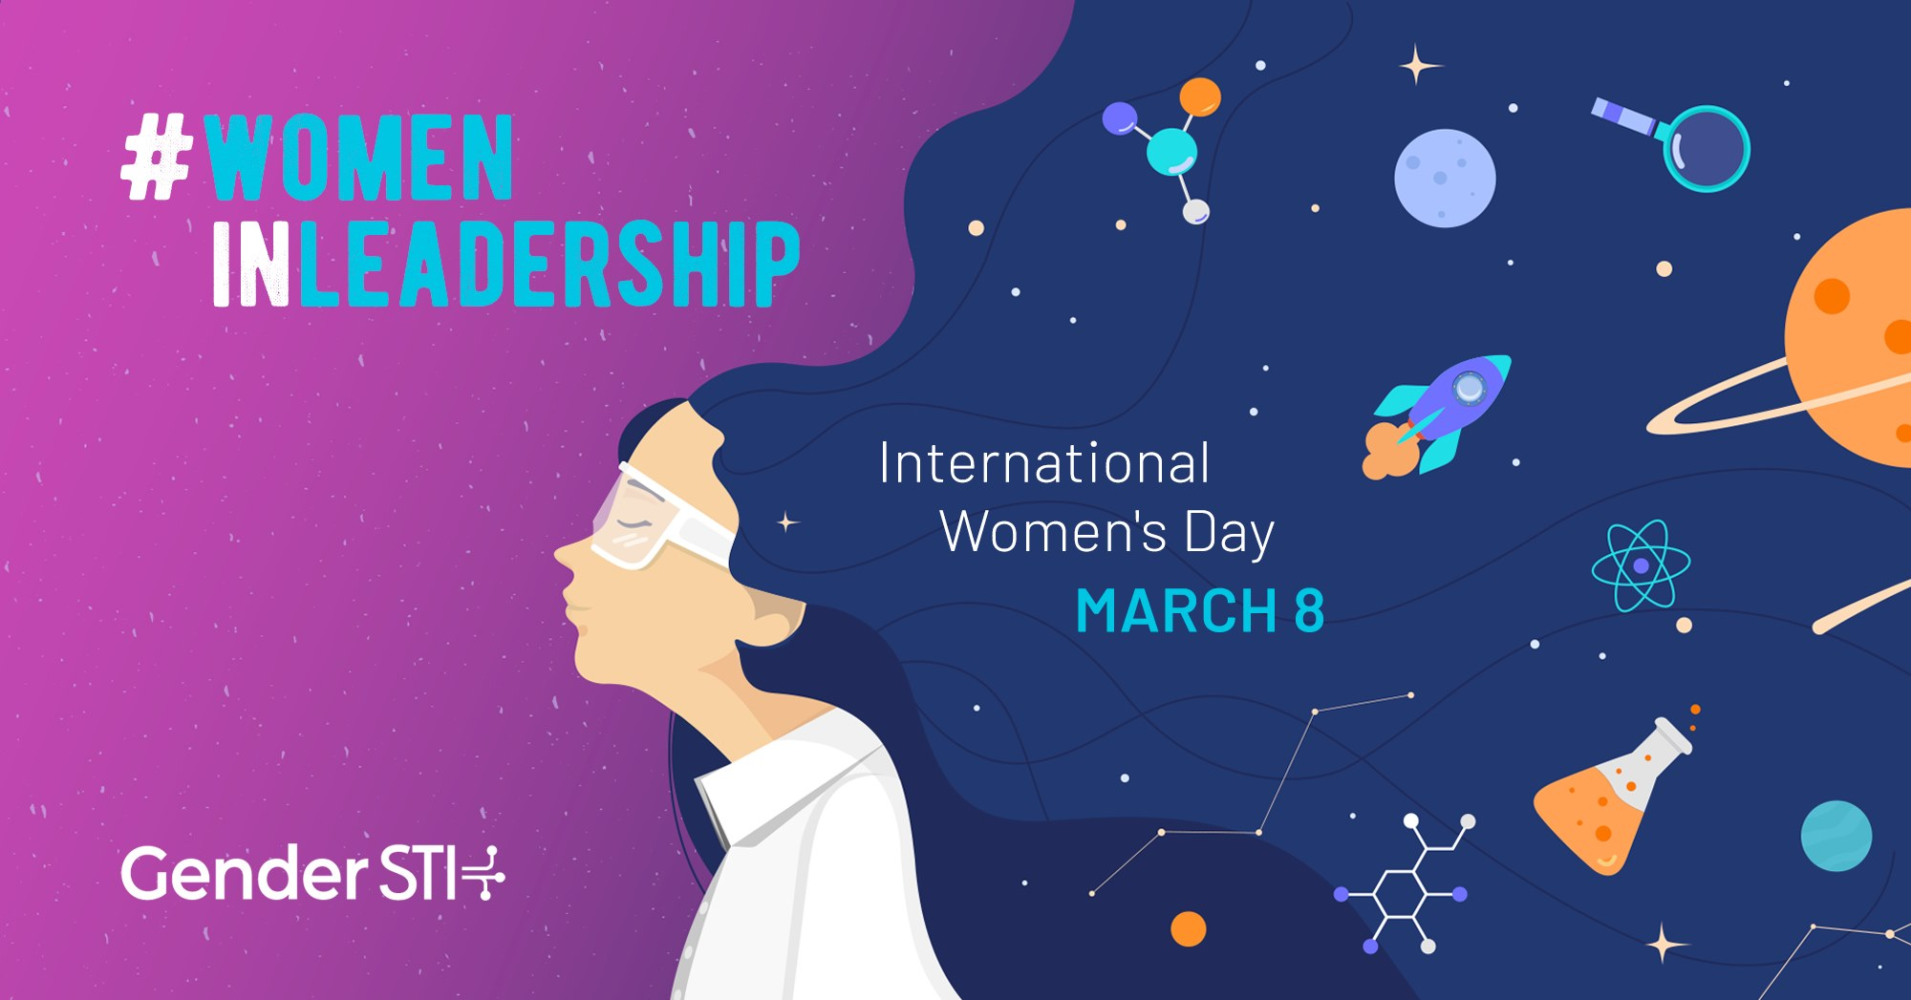
2 - https://www.gender-sti.org/women-in-leadership-campaign-iwd-2021/

Future of Work and Disability
The Future of Work and Disability project is in the process of preparing a report that summarizes the project's efforts to understand and examine intersecting topics of AI, automation, standards and employment as they relate to persons with disabilities with the assistance of their fifteen-person study group.
In addition to the report currently under development for Accessibility Standards Canada, the FWD project created:
Learning opportunities from our webinars
Badges that can be used by learners to demonstrate their proficiency in the field
A learning program that will be publicly available at the close of the project
Find out more about the project in the Future of Work and Disability summary.

Learn More
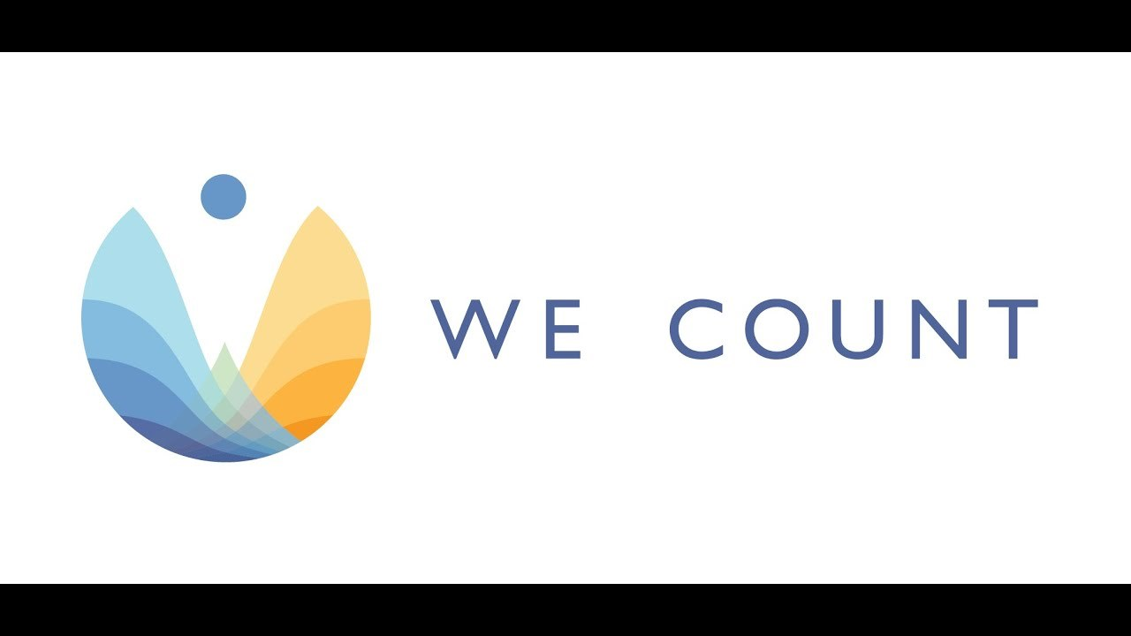
Discover how We Count is addressing bias and developing new machine learning strategies that recognize and serve people with disabilities in this video.

Are you interested in hearing about We Count activities or do you want to be contacted to learn about ways you can participate? If you are, then send us your contact information using our contact form.

Contact Us
We would love to hear from you!
Inclusive Design Research Centre
OCAD University
205 Richmond St. W, Toronto, ON, M5V 1V3
wecount@inclusivedesign.ca
Visit the We Count website and follow us on social media (@WeCountProject).

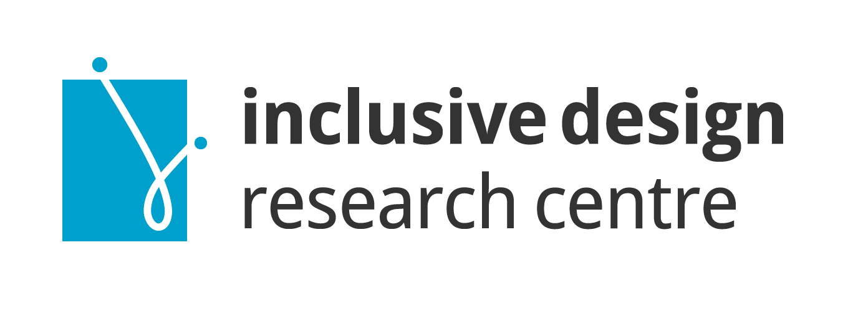
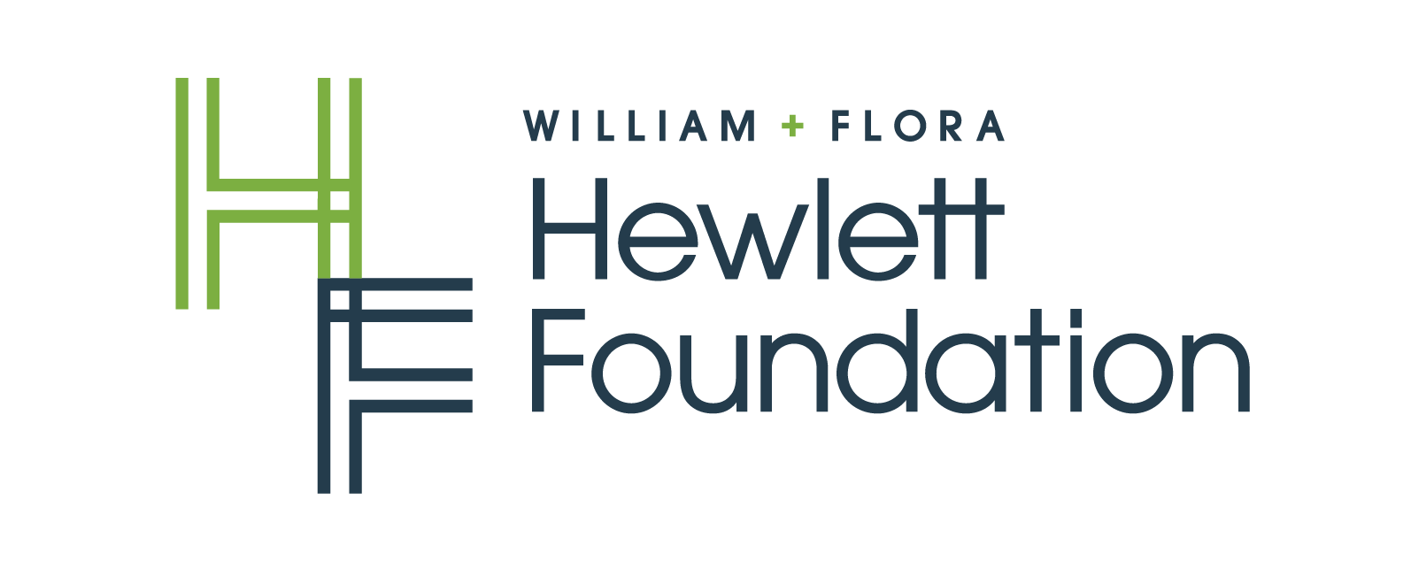
We Count acknowledges the support of:

