The We Count Recount: June 2021
We Count is a community-driven project that addresses the inherent bias against small minorities and outliers in artificial intelligence and data analytics.

A Message from Our Director
Friends and colleagues,
One of the lessons of the We Count project is that data is not objective, it is not synonymous with truth, and it will never tell the whole story. Every stage of the data life-cycle is biased: what questions are asked, what is posed as a hypothesis, how the hypothesis is proved or disproved, what data is collected, how the data is analyzed, and how this guides decisions. At each stage there is a choice to ignore and make invisible a part of the truth. What the data means and what can stand in for missing data is interpreted subjectively. To make matters worse, data systems tend to become self-reinforcing and self-perpetuating. Not only does what is measured get done, but what is measured becomes the norm that people conform to and accept as convention. What is measured becomes what is valued.
One of the casualties of currently accepted data practices is the perspectives and truths of minorities. Despite what we know about the fallibility of data, majority data not only rules but is sanctioned as the basis of proof and is seen as the truth.
One of the questions we have been asking in the We Count project is: What are the risks to minorities in a world where majority rules? A particularly troubling risk is the risk to a sense of identity and self-worth. In We Count we are looking at ways to wrest back control over your own data and how it is used. How can we defend the truths that are made invisible and devalued by our data practices? How can we as a society find a way to acknowledge a more complete and diverse truth?
We will be organizing more opportunities to collectively explore these questions and to co-design more inclusive alternatives. Please join us.
All my best,
Jutta

News from the Field
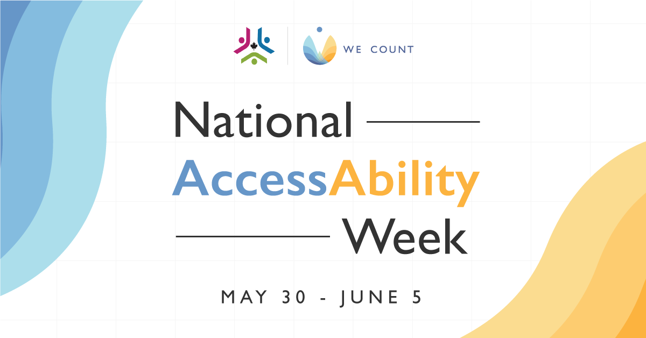
Happy National AccessAbility Week!

Making Geology Accessible for Blind Students
With few resources to support a blind student studying geosciences, a University of Kentucky professor created a library of tactile graphics as a way to share visual data and make geology classes more accessible. The resource set has been shared for others to use and add to.

Artificial Intelligence and Accessibility: Examples of a Technology that Serves People with Disabilities
AI has the power to revolutionize accessibility and inclusion. Discover how accessible AI technology can benefit the lives of persons with disabilities.

Microsoft Announces "Doubling Down" on Prioritizing Accessibility and Narrowing the Disability Gap
Microsoft announced a new five-year initiative designed to help bridge the "disability divide." The program will focus on accessibility tech, talent development and inclusive workspaces.

Physics Webpages Create Barriers to Participation for People with Disabilities
A new paper reveals five common accessibility errors identified on university physics webpages, their solutions, and their implications.

Making Kin with the Machines
Learn how Indigenous epistemologies can be used to analyze AI's place in society and its development in this essay by Jason Edward Lewis, Noelani Arista, Archer Pechawis and Suzanne Kite.

We Are AI
Want to learn more about AI? Try this five-week learning circle course on the basics of AI, the social and ethical dimensions of AI, and how AI is used.

A.I. Nation
A.I. Nation, a new podcast from WHYY and Princeton University, reveals how AI is operating in the background, and sometimes foreground, of every major story, trend, and event in our modern lives.

The Chronicles of AI Ethics: The Man, the Machine, and the Black Box
This Forbes article by Aparna Dhinakaran discusses how major technological advances are imperfectly regulated and effectively shielded from social responsibility, while their users face major repercussions.

Want to Get Along With Robots? Pretend They’re Animals
This Wired article presents an interesting take on the human-AI relationship and how we can reframe how we interact with AI.

AI Has a Racism Problem, but Fixing It Is Complicated, Say Experts
AI is used for translation apps and other software, but as this CBC article explores, it isn't able to differentiate between legitimate terms and ones that might be biased or racist.

This Month

New W3C Group: Portable Personal Data Preferences Community Group
We need your support!
A new W3C group has been created by the IDRC to address problems with terms of service agreements. Often, these agreements are complicated and require an all-or-none acceptance or rejection and may also be in a form that is not accessible to persons with disabilities, making it difficult to make an informed decision. The mission of this community group is to find ways to help consumers access and understand what they are being asked to commit to, as well as provide a finer level of control in terms of what they are willing to share.
People interested in educating consumers regarding personal data and data sharing, inclusive user interface design, and the use of plain language in policies and service agreements are encouraged to participate once the group is launched.
You can join the Personal Data Preference Group now.
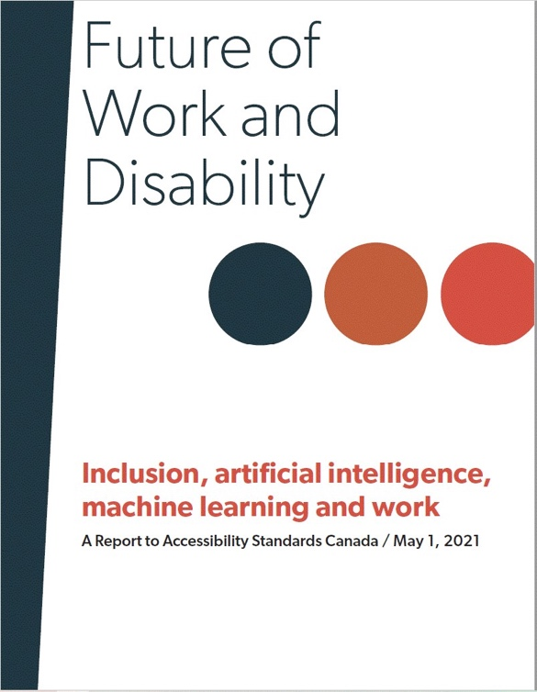
1 - Future of Work and Disability Report

Future of Work and Disability Report
The Future of Work and Disability project has released a report that summarizes the group's efforts to understand and examine intersecting topics of AI, automation, standards and employment as they relate to persons with disabilities.
You can download the report in English or French or find out more about the project on the Future of Work and Disability website.

Initiatives

The Metric Society and the Unmeasurable
The Metric Society and the Unmeasurable webinar, with Steffen Mau, Virginia Eubanks and Jutta Treviranus in conversation, is now available for viewing! The webinar is a fascinating discussion about the implications of how metrics have become a form of social conditioning, impacting everything from annual university rankings, ratings agencies and fitness tracking technologies to our credit score and health status.
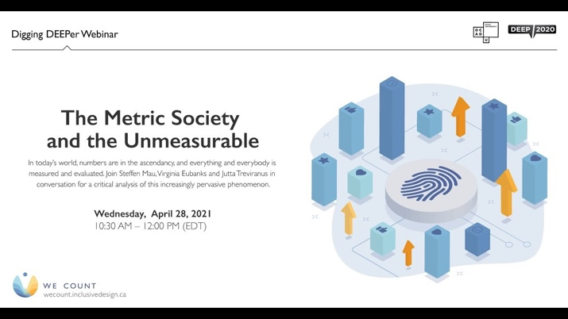
2 - The Metric Society and the Unmeasurable

COVID-19 Vaccination Centre Data Monitor: Accessibility Map Demonstration
With the evolving COVID-19 public health measures and rapid emergence of testing centres, there were several access barriers to obtain information to get tested for COVID-19.
Our team has created a map demonstration to show how these data gaps can be addressed, providing a way to find accessibility information that is not included in these data sets. The map demonstration uses an example data set and demonstrates how data visualization can be designed in an accessible format. Accessibility features in the map include: accessible entrances, accessible washrooms, accessible parking, individual service and wait accommodations.
Find out more about the map and try it out on our Views page.
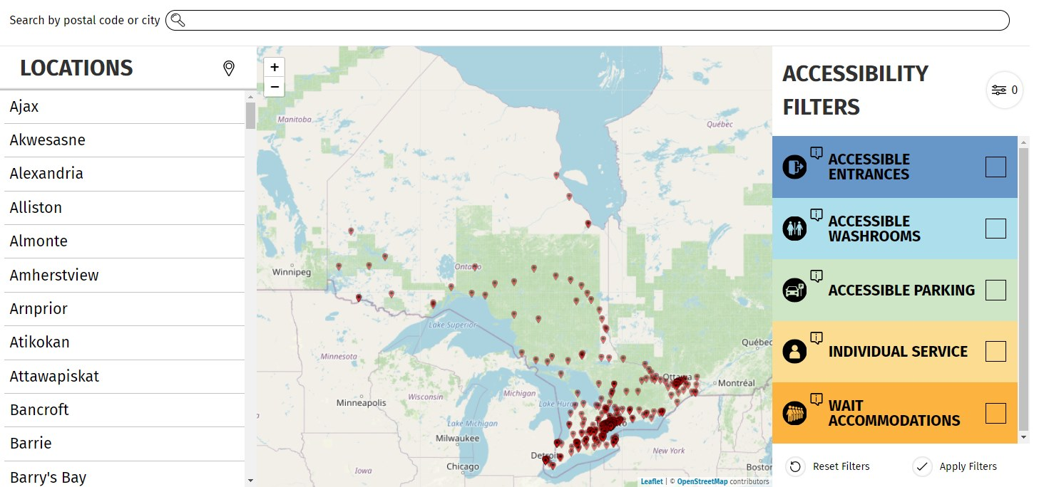

Inverted Wordles
When word cloud centres build wordles based on people's answers to a question, majority answers are emphasized while minority answers fade to the background. In order to make minority voices heard, the development team is building a wordle tool that allows users to have the option to flip the algorithm to highlight minority or majority answers.
Find out more about the project on our Views page.
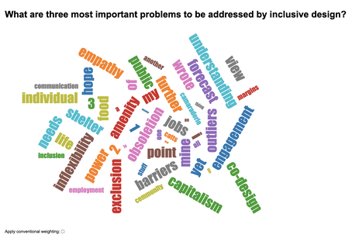
Discover how we're helping to create an inclusive and balanced data ecosystem for persons with disabilities through our ongoing call for challenges and challenge workshops.
Future of Work and Disability: Bias in Candidate Selection
It's not too late to participate in our Future of Work and Disability webinar series!
Our installment on Bias in Candidate Selection explores policy through a co-design activity, working in groups to co-create approaches to AI and ML challenges in employment systems. This webinar features:
Abhishek Gupta, Montreal AI Ethics Institute
4 - Future of Work and Disability: Bias in Candidate Selection
Visit our YouTube channel to see past webinar recordings. New videos are released regularly, so be sure to subscribe.

We Count Badges
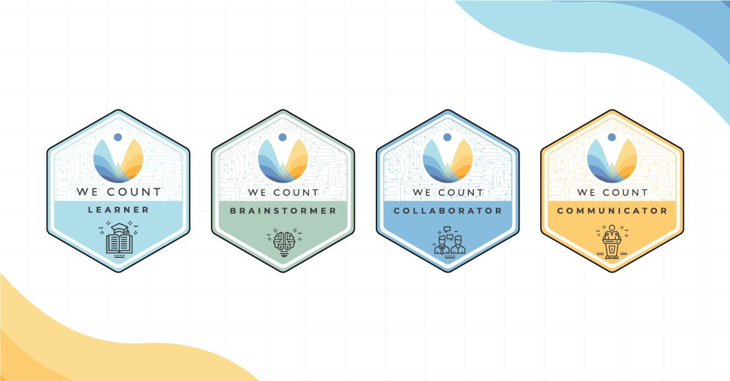
Earn badges with We Count! Our badges enable earners to showcase their proficiency in AI, data systems and inclusive data practices. To find out more about the types of badges we offer and which badges are currently available, visit our website.
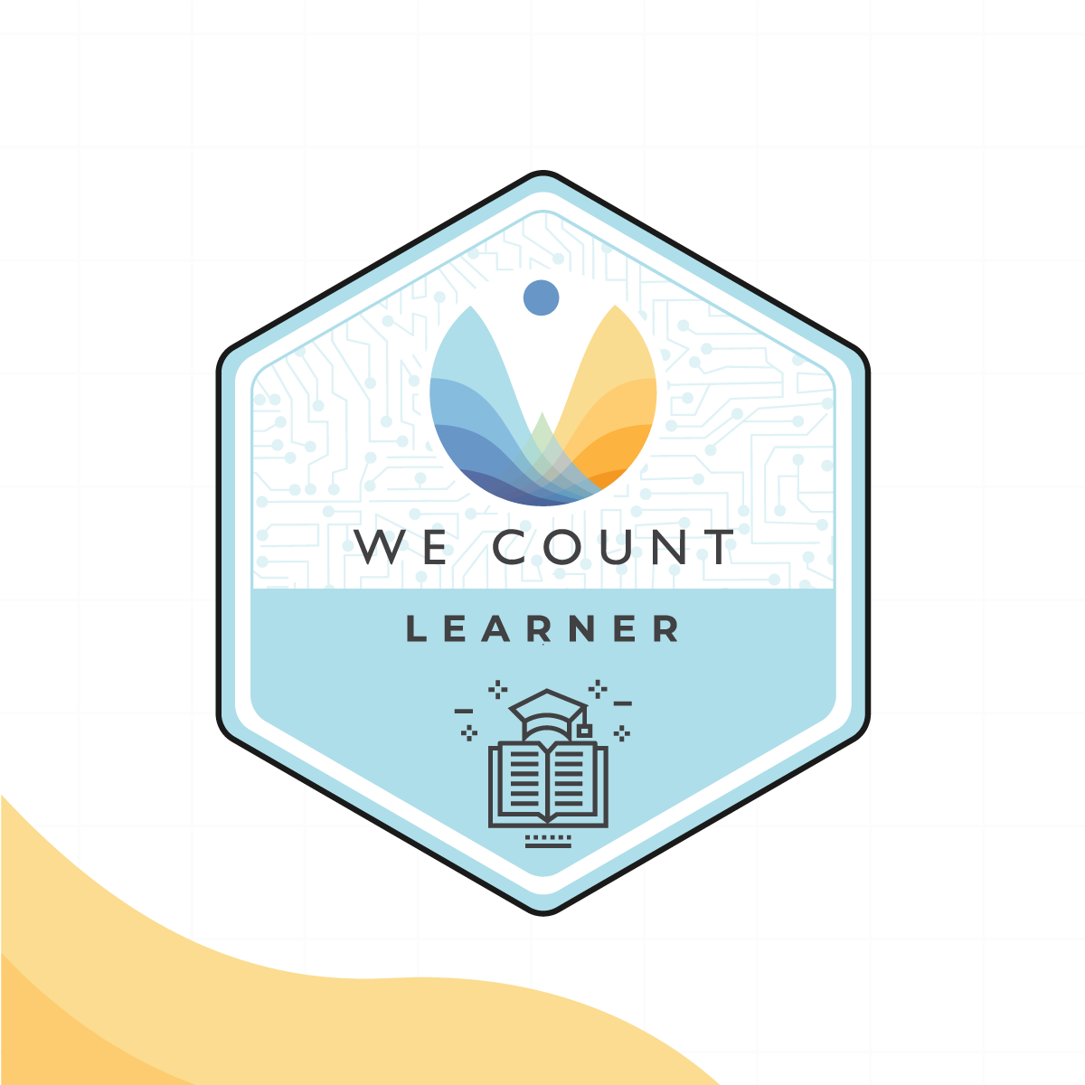
Badge Spotlight: The Metric Society and the Unmeasurable Learner Badge
In this webinar, Steffen Mau, Virginia Eubanks and Jutta Treviranus discuss the emergence of societies dominated by star ratings, scores, likes and lists, as data is collected on virtually every aspect of our lives. From annual university rankings, ratings agencies and fitness tracking technologies to our credit score and health status, everything and everybody is measured and evaluated.
You will learn:
How the rise of quantification has created and strengthened social hierarchies
How quantification could lead to standardization but does not necessarily capture social diversity and deviance
About the importance of bottom-up, community-driven initiatives in addressing the top-down mismanagement of personal data and access to social services
Apply for this badge on our Initiatives page.

IDRC News
Equitable Digital Systems
The Future of Work: Equitable Digital Systems project is an IDRC initiative that examines the accessibility of the digital tools and systems we rely upon for work to ensure that they are meeting the needs of and enabling work for people with disabilities. The project looks specifically at systems used by organizations that are regulated by the Accessible Canada Act, Bill C-81.
To fill the regulatory gaps that we find in our research, we are hosting co-design sessions with our partner organizations and people with disabilities, as well as developing an accessible open online resource site where our research will be stored that will provide people with disabilities with up-to-date and accurate information about emerging technology.
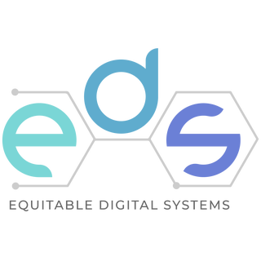
Throughout the Equitable Digital Systems project, people with disabilities will lead the direction and outcomes of research, as we carve a path toward equitable and inclusive digital systems.
Visit our website to learn more about the project.

Learn More
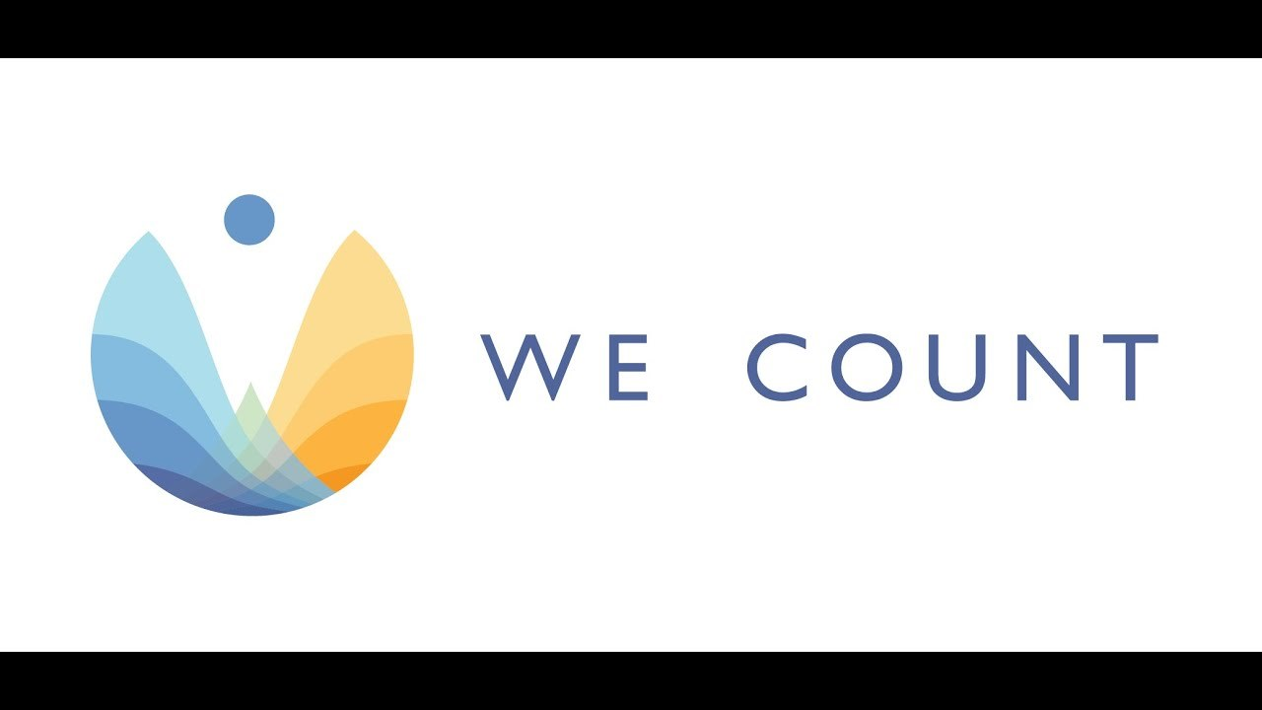
Discover how We Count is addressing bias and developing new machine learning strategies that recognize and serve people with disabilities in this video.
Are you interested in hearing about We Count activities or do you want to be contacted to learn about ways you can participate? If you are, then send us your contact information using our contact form.

Contact Us
We would love to hear from you!
Inclusive Design Research Centre
OCAD University
205 Richmond St. W, Toronto, ON, M5V 1V3
wecount@inclusivedesign.ca
Visit the We Count website and follow us on social media (@WeCountProject)

We Count acknowledges the support of:
