The We Count Recount: April 2021
We Count is a community-driven project that addresses the inherent bias against small minorities and outliers in artificial intelligence and data analytics.

A Message from Our Director
Friends and colleagues,
Impact is determined by how many people benefit from the same thing, evidence by how many repeatable effects can be documented in research, worthiness by how many people support the same action in votes or petitions. In the civilization we have created, truth and value come down to counting things that are the same. What if you are different, so different that there isn’t anyone like you, but your needs are critical? You won’t have impact, evidence or worthiness behind you. These are the incentives needed by researchers, politicians and investors.
This pattern is amplified and automated in our technical systems. We have designed our technology so that value comes down to popularity or profit. What is “liked” gets attention and becomes more popular. What is deemed profitable gets more investment and becomes more profitable.
When technology is used to optimize productivity, efficiency or learning, it uses data from the past to optimize the patterns of the past. What if your interests are not popular and your contribution has not been monetized? What if there is no data about you because you haven’t been given a chance to participate? Worse yet, you won’t be understood and you’ll be flagged as an anomaly by security systems.
… and yet we know that diversity and diversification is the key to our survival.
These are some of the conundrums we are exploring in the We Count project, with our guest speakers Steffen Mau and Virginia Eubanks and our co-design sessions.
All my best,
Jutta

News from the Field

Quantization Podcast, Episode 16
Dr. Jutta Treviranus and Bianca Wylie discuss housing and homelessness in this Quantization podcast episode.

Industry AI Ethics 101
Find out what designing ethical AI actually entails in this Radical AI Podcast episode with Kathy Baxter.
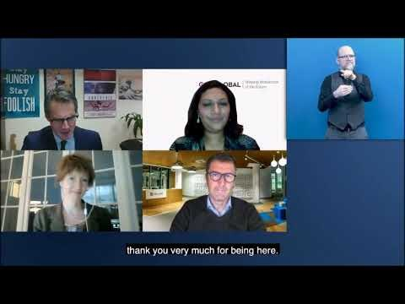

An Inclusive Digital Economy for People with Disabilities
This Zero Project webinar brings awareness of the impact of a digital world of work on people with disabilities and identify actions needed to shape a future of work in a more disability-inclusive way.

Stories of Transformation
In this Universal Design in Life and Work podcast episode, Dr. Jutta Treviranus talks about inclusive design versus universal design, AI bias and non-linear logic models.

Algorithms and the Coronavirus Pandemic
Check out this Financial Times article about the increasing public backlash over governments’ use of automated decision making tools.

Algorithmic Fairness
In this Intel on AI podcast episode, Alice Xiang and Abigail Hing Wen discuss the goals of the Partnership on AI, the importance of being able to explain AI model reasoning, and the proliferation of criminal justice risk assessment tools.

How Do You Lip Read a Robot? – Recruitment AI Has a Disability Problem
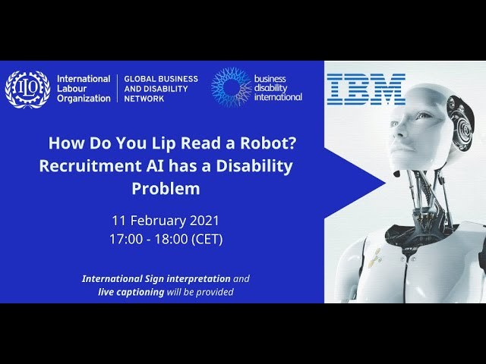
Explore the unacknowledged risks to the more than 1.3 billion persons with disabilities that are triggered by the fast-growing use of AI-powered recruitment tools in this Zero Project webinar.

How Can the AI Sector Improve Diversity Standards?
Nikolas Kairinos delves into the difficult subject of diversity standards in the AI space and highlights the importance of transparency in this Open Access Government article.

In AI (Can) We Trust?
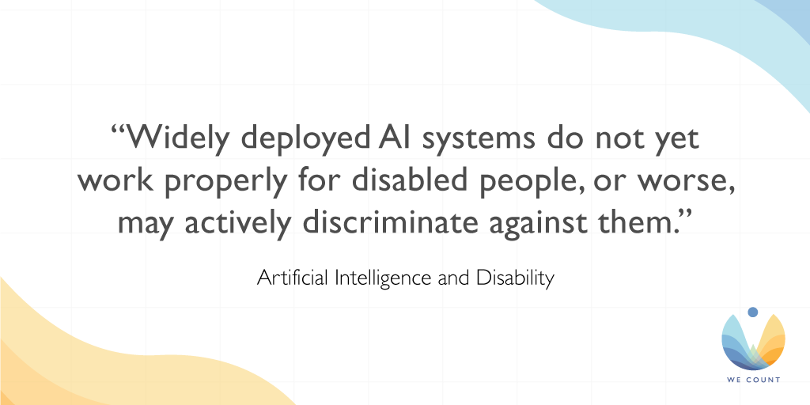
This Forbes article discusses whether AI decision-making can be trusted, suggesting that the root of the problem goes far deeper than AI ethics, becoming a question of human morality and how "fairness" is defined.

Artificial Intelligence and Disability: Too Much Promise, Yet Too Little Substance?
Read and comment on this opinion piece that explores the day-to-day realities of how AI can support, and frustrate, disabled people, drawing conclusions about how AI might best be developed in the future.

AI Needs to Face Up to Its Invisible-Worker Problem
Did you know that machine learning models are trained by low-paid online gig workers? Find out more in this interview with Saiph Savage.

The Algorithm Audit: Scoring the Algorithms That Score Us
Read about a new proposed framework for auditing algorithms in this Big Data & Society paper.

The Algorithmic Auditing Trap
Learn about the promise and pitfalls of algorithmic assessments in this op-ed by Mona Sloane.

This Month
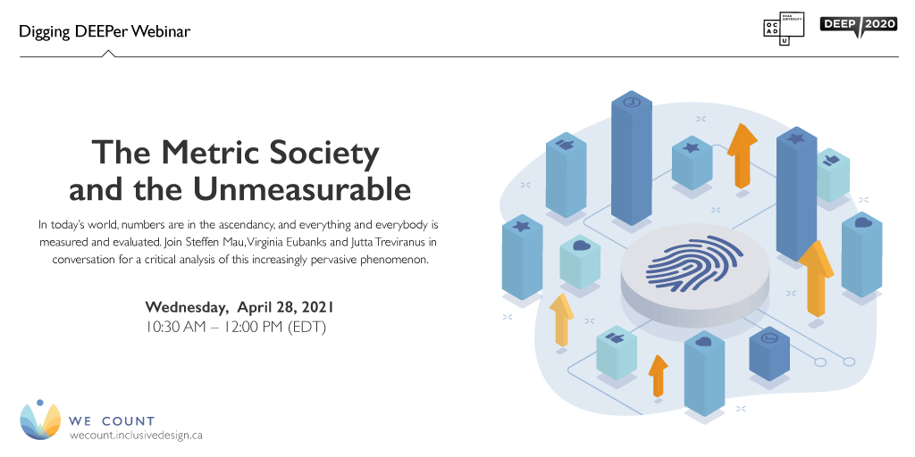
The Metric Society and the Unmeasurable
In today’s world, numbers are in the ascendancy. Societies dominated by star ratings, scores, likes and lists are rapidly emerging, as data are collected on virtually every aspect of our lives. From annual university rankings, ratings agencies and fitness tracking technologies to our credit score and health status, everything and everybody is measured and evaluated. Join Steffen Mau, Virginia Eubanks and Jutta Treviranus in conversation for a critical analysis of this increasingly pervasive phenomenon.
Wednesday, April 28, 2021, 10:30 AM – 12:00 PM (EDT)

Initiatives

What Is a We Count Challenge?
Watch We Count's latest video and discover how we're helping to create an inclusive and balanced data ecosystem for persons with disabilities through our ongoing call for challenges.

Building Indigenous Future Imaginaries
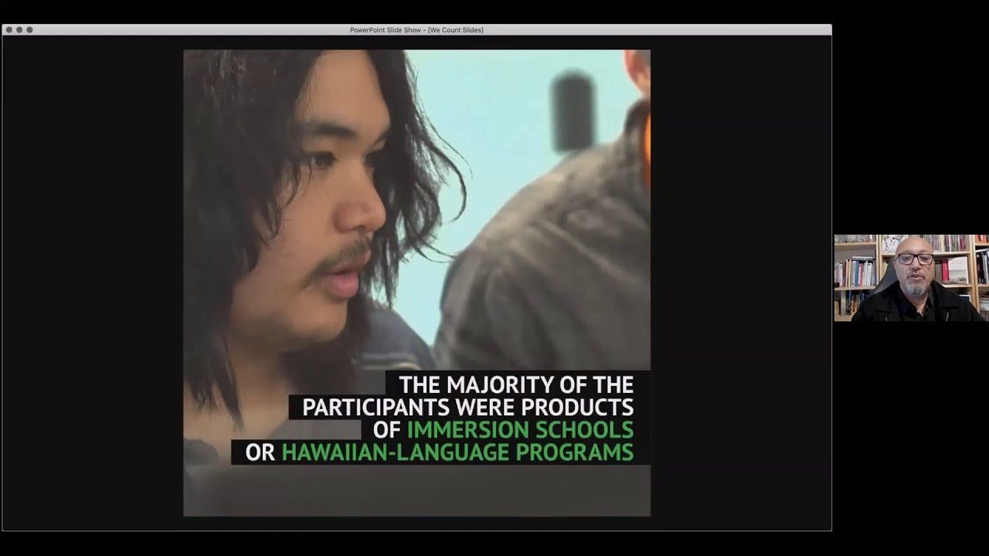
Our Building Indigenous Future Imaginaries webinar video is now available on our website and YouTube channel! Based on Jason Lewis’s research-creation work, this webinar explores the concept of the future imaginary and makes an argument as to why it is important that Indigenous people engage in creating them.

Future of Work and Disability: AI Hiring System Policies
It's not too late to participate in our Future of Work and Disability webinar series!
Our second installment on AI Hiring System Policies delves into how machine learning models can carry bias when selecting candidates, affecting persons with disabilities and other individual differences. This webinar features:
Alexandra Reeve Givens, Center for Democracy & Technology
Julia Stoyanovich, New York University
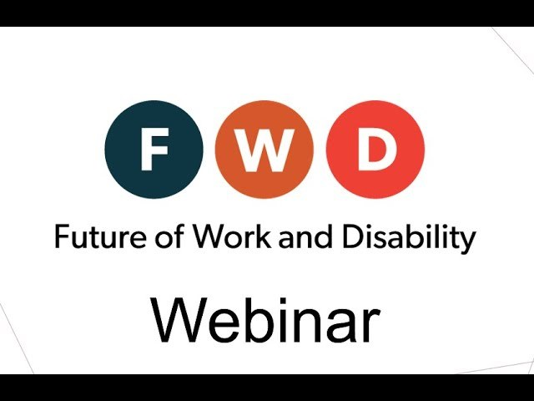

Visit our YouTube channel to see past webinar recordings. New videos are released regularly, so be sure to subscribe.

We Count Badges
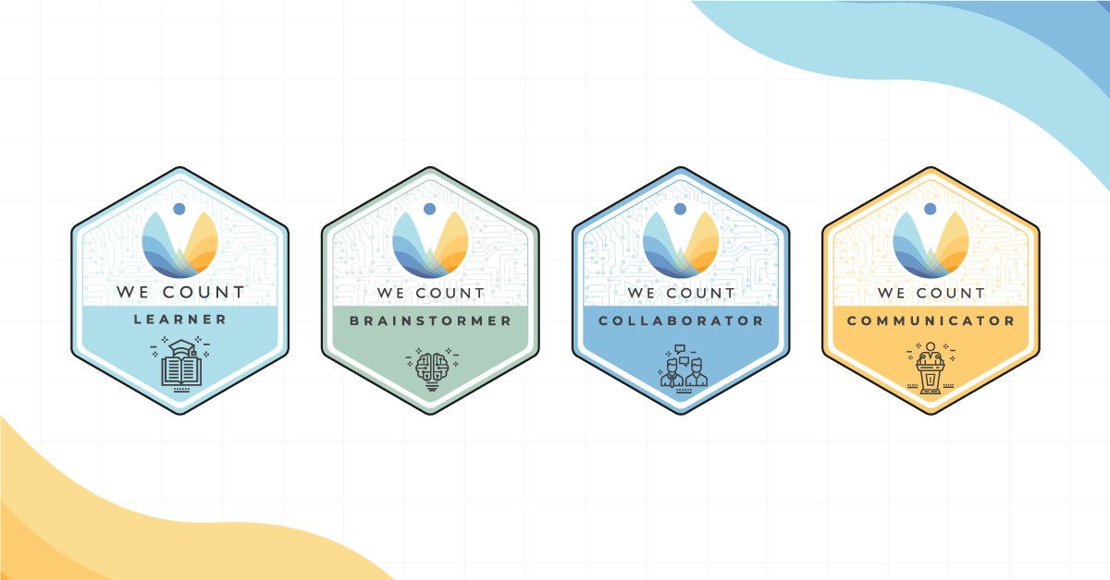
Earn badges with We Count! Our badges enable earners to showcase their proficiency in AI, data systems and inclusive data practices. To find out more about the types of badges we offer and which badges are currently available, visit our website.
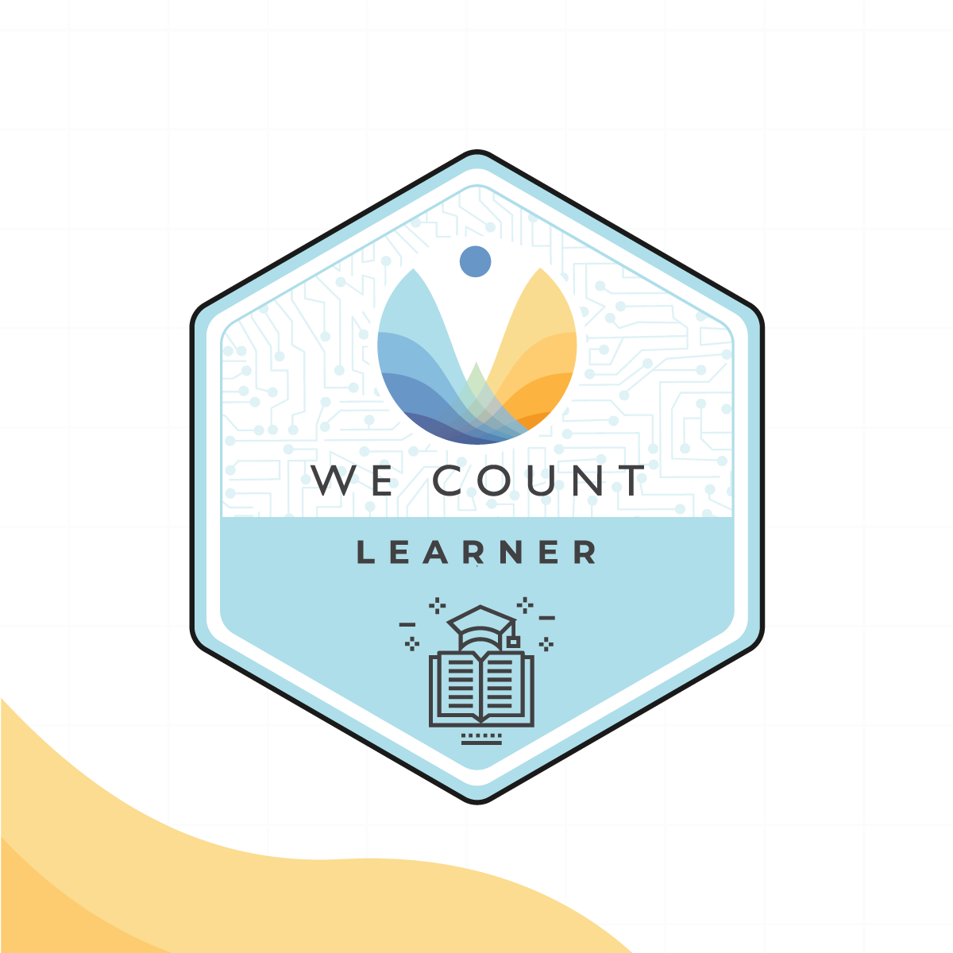

Badge Spotlight: AI and AT Apps Learner Badge
The AI and AT Apps webinar digs deeper into the possibilities of AI-powered assistive technology mobile apps and focuses on an important question: Artificial intelligence is rapidly advancing to think like us and to deep dream through machine learning, so how can it be used to improve accessibility?

For the AI and AT Apps Learner badge you will learn:
How AI systems within various commercial software applications impact persons with disabilities and marginalized communities
About accessibility features and design considerations present in current assistive technology applications
By sharing your experience with technology in an AI-supported world in a succinct and organized format
Apply for this badge and explore the other badges in this series on our Initiatives page.

IDRC News

Open Robot Kit
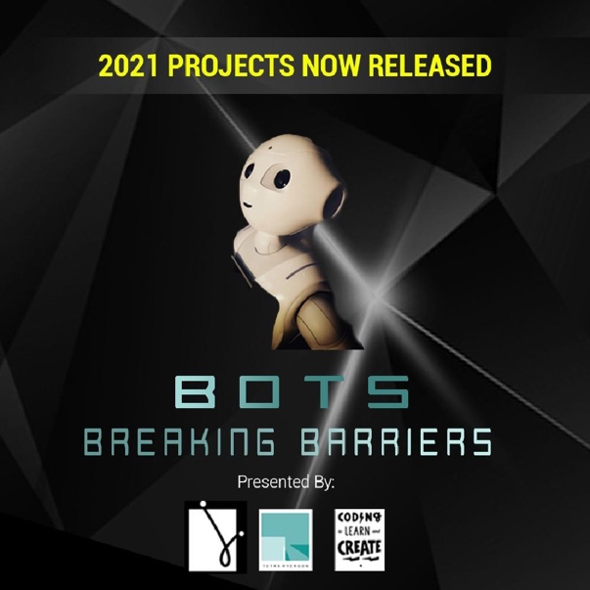
Weavly (formerly the Inclusive Coding Environment) is being designed to work with a variety of coding robots. Off the shelf robots are often inaccessible for many learners, which is why Tetra Ryerson is creating an Open Robot Kit to enable educators to easily create a "one-size-fits-one" robot that works with Weavly.
Students are working in groups to create robots that are reasonably affordable, composed of easy to acquire parts, robust and safe enough for students to play with. The robots are designed with composable parts and will have a Robot Building Guide with easy to follow instructions. The guide will be freely available in the Educator’s Toolkit.
Learn more about the kit on the Coding to Learn and Create website.

Community Workshops and Design Crits
On Tuesdays, the inclusive design community gathers together to learn and discuss various topics in the form of a workshop or a design critique.
Workshops provide the inclusive design community with an opportunity for engaging with a broader community to stimulate creative processes.
Design critiques are an opportunity for community members to examine and discuss a creative artifact in an informal and constructive setting.
The next event on April 20 is a design critique entitled "Looseleaf: CSS for Prototyping." Visit the Wiki page for more information.

Learn More
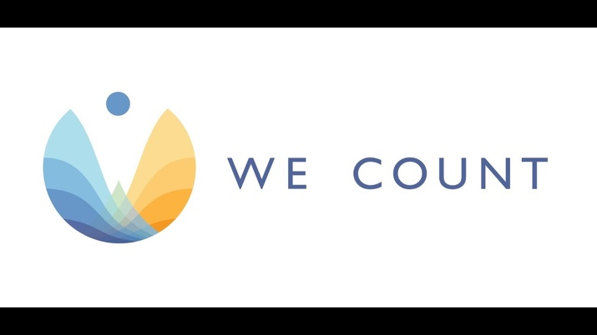

Discover how We Count is addressing bias and developing new machine learning strategies that recognize and serve people with disabilities in this video.
Are you interested in hearing about We Count activities or do you want to be contacted to learn about ways you can participate? If you are, then send us your contact information using our contact form.

Contact Us
We would love to hear from you!
Inclusive Design Research Centre
OCAD University
205 Richmond St. W, Toronto, ON, M5V 1V3
wecount@inclusivedesign.ca
Visit the We Count website and follow us on social media (@WeCountProject).

We Count acknowledges the support of:
